Procedure to Install UV Ring System on 1800 Machine, new 1800, 1500

# Purpose

## Intended audience

Production, engineering, integration, sales & marketing personnel

## Contents of UVR installation kit

|  |  |  |  |
| --- | --- | --- | --- |
| Qty | Cat No | Part |  |
| 1 | ASM-01476A | UVR HEAD | 1 |
| 1 | ASM-01479A | DRIVER | 2 |
| 1 | PRT-01650A | BRACKET UV HEAD ASSY | 3 |
| 3 | SCR-40076 | SCREW SEMS M4X8 | 4 |
| 3 | NUT-001000 | NUT,SLOT,M4,MULTI AXIS,ST | 5 |
| 1 | PRT-30891A | ALIGNMENT TOOL | 6 |
| 1 | MA-01-5257 | CABLE-CONTROLLER-UVR | 7 |
| 1 | MA-01-5258 | CABLE-UVR CONTROLLER TO BECKHOFF | 8 |
| 1 | MA-01-5259 | CABLE-UVR POWER | 9 |
| 1 |  | 50cm Blake wire 20AWG | 10 |
| 4 | CLS-M4-2 | Self- clinching nuts | 11 |
| 4 | SCR-40076 | SCREW SEMS M4X8 | 12 |
| 20 | 125X2.5mm | Cable tie | 13 |

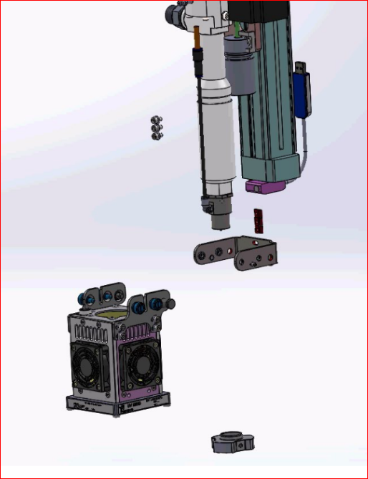



## General Description of installation procedure

1. Turn off the machine and disconnect the power to it.
2. Disassemble the old UV lamp, including the seating

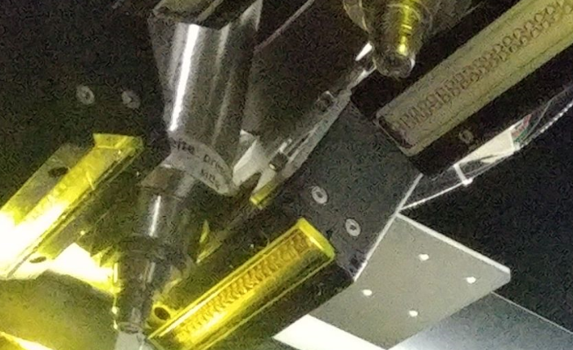

1. Connect the new clamp to the [Z axis] using 3 screws (don’t tighten)

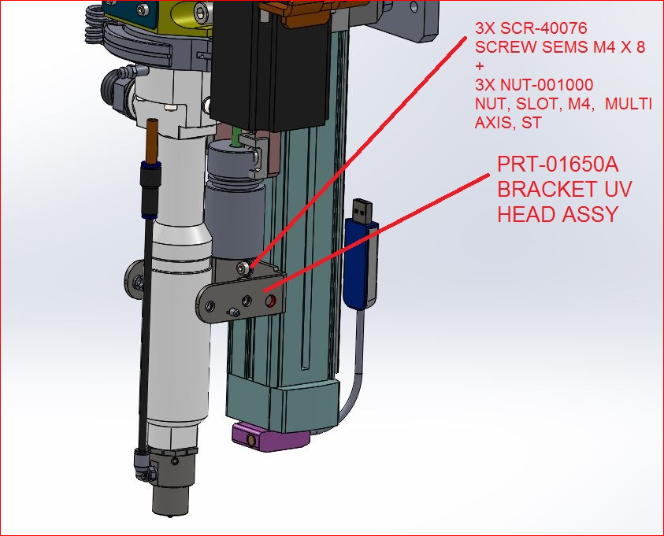

1. Connect the UV lamp to the clamp using 2 pins and 4 screws

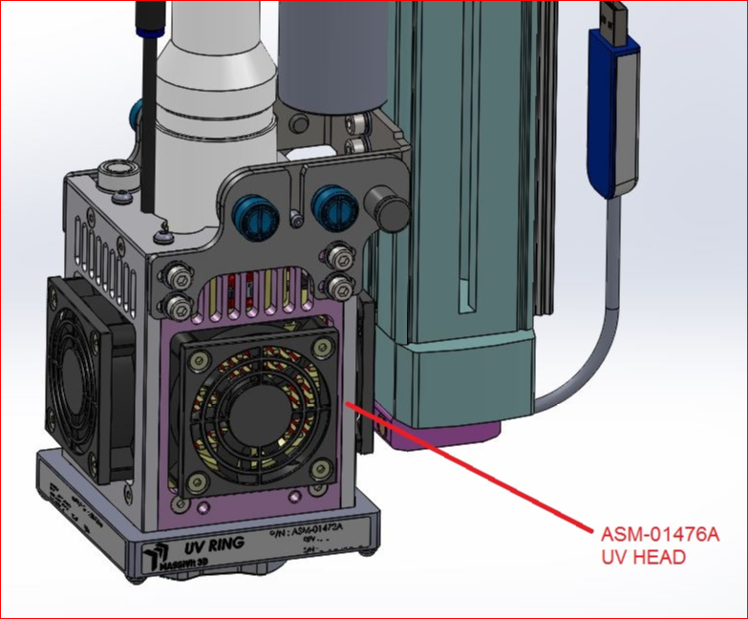

1. Using the jig, adjust the UV lamp to the correct height in the center of the [?]
2. The correct height is 15 mm from the glass to the bottom edge (the tip)

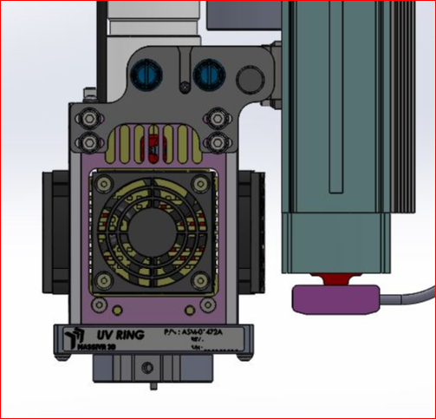

1. Tighten the three (3) bracket screws
2. Thread the cable (12-strand) through the [] until it reaches the electrical cabinet.
3. Connect the round electrical connector {?] to the UV lamp by turning it lightly until [??], and then pressing the case down.

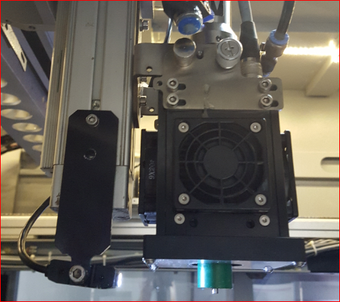

bracket

Round connector

1. Connect the 15-pin D connector to the driver [box] in the old 1800 electrical cabinet as follows:.
   1. The driver [box] is installed in the electrical cabinet opposite the top covering (on the panel with two fans)
   2. Connect the 12-pin D-type connector to the Driver.
   3. Route all cables in harnesses

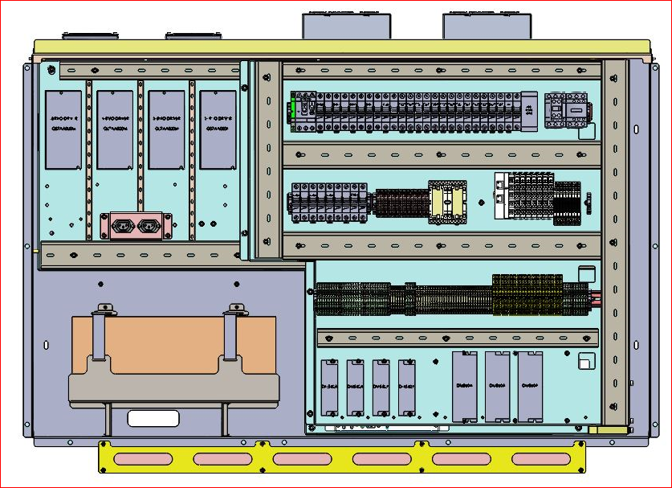

1. Connect the 25-pin cable (MA-01-5258) to the main left box [?], as follows, and lay the cable [?]
   1. TB A03 and A04 are in the left box:
   2. Connect INTENSITY 1 and INTENSITY 2 to A03
   3. Connect INTENSITY 3 and INTENSITY 4 to A04
   4. Connect ENABLE 1 and ENABLE 2 to D03
   5. Connect ENABLE 3 and ENABLE 4 to D04
2. Connect the 25-pin cable (MA-01-5258) to the main right box as follows:
   1. TB A01 and A02 are in the right box
   2. Connect INTENSITY 1 and INTENSITY 2 to A01
   3. Connect INTENSITY 3 and INTENSITY 4 to A02
   4. Connect ENABLE 1 and ENABLE 2 to D01
   5. Connect ENABLE 3 and ENABLE 4 to D02
3. Insulate and tie up the 4 READY strands in each of the MA-01-5258
4. Leave the TEMP strand exposed (at end of the installation, insulate it)
5. Connect the power supply to the power connections in the old 1800 cabinet as follows:
   1. Connect the power cable MA-01-5259 to the DRIVER box, and pass the cable through the channel towards relay R13
   2. Connect the RED strand on the right side to pin 24 on relay R13
   3. Connect the RED strand on the left side to pin 34 on relay R13
   4. Insulate the WHITE strand and tie it up
   5. Connect the BLACK strand to TB-48
   6. Connect the BLACK strand AWG20 to short between TB 48 and TB 24
   7. Connect a digital voltmeter between the fasteners, and confirm 48V, and also confirm 48V between pin 24 in relay R13 on the right side and pin 34 in relay R13 on the right side
   8. Adjust the small screw [?] to adjust the 48V power voltage of the UV to 52V
   9. Power supply PS2 is for the right head, and PS1 for the left.
6. Connect the 15-pin D-type connector to the DRIVER box in the electrical cabinet of the new 1800 as follows:
   1. In the electrical cabinet opposite the power panel at the top, approx. 10cm to the right of the MOONS DRIVER, place the DRIVER card box (with the small side upwards), and affix it to the metal, parallel to the MOONS DRIVER (check that the power supply connector is on top).
   2. Mark the locations of the holes, and drill four (4) 4mm holes in the wall.
   3. Ensure that no debris from the drilling enters the computer or any other electrical device.
   4. Thread the holes for 4M screws, and connect the box with 4 screws and washers.
   5. Connect the 12-pin D-type connector to the DRIVER box.
   6. Channel all the cables through the channels

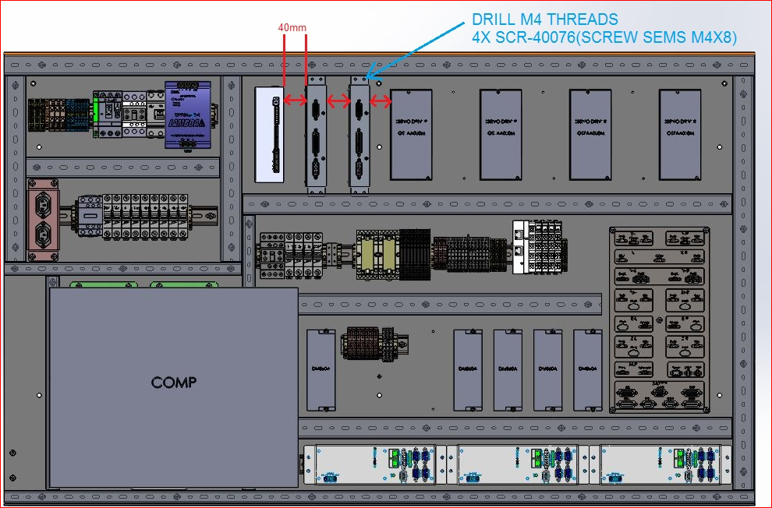

# Installation Procedures

## Installation Procedure for Driver card in an older 1800 machine cabinet

## UVR Installation procedure for 1500 machine

## Verification of installation